Asi Help Database Update

- Shut down database for help db

  - Go to the START menu on the server
  - Programs
  - Progress
  - Procontrol

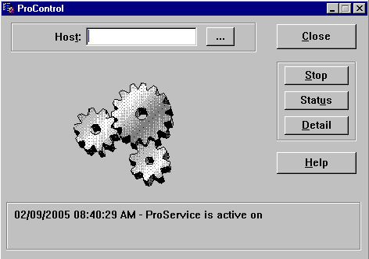

Click on Status button

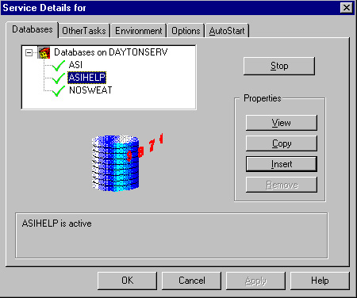

Click on Help DB
Click Stop

The Help database is stopped at this point.

- Copy new files from the cd to the db folder on the server

Go to START run
Type in cmd on the open line

Type this

cd\program files\progress\bin [ENTER]
prostrct repair d:\asigui\db\asihelp [ENTER]
Exit [ENTER]

Note: Please Check your drive letter for the db. This can change from customer to customer.

  - Go to the START menu on the server
  - Programs
  - Progress
  - Procontrol

Click on Status button

Click on help
Click on start button

The database should be running at this point.

